Verktøykasse for:

VERDISEMINAR
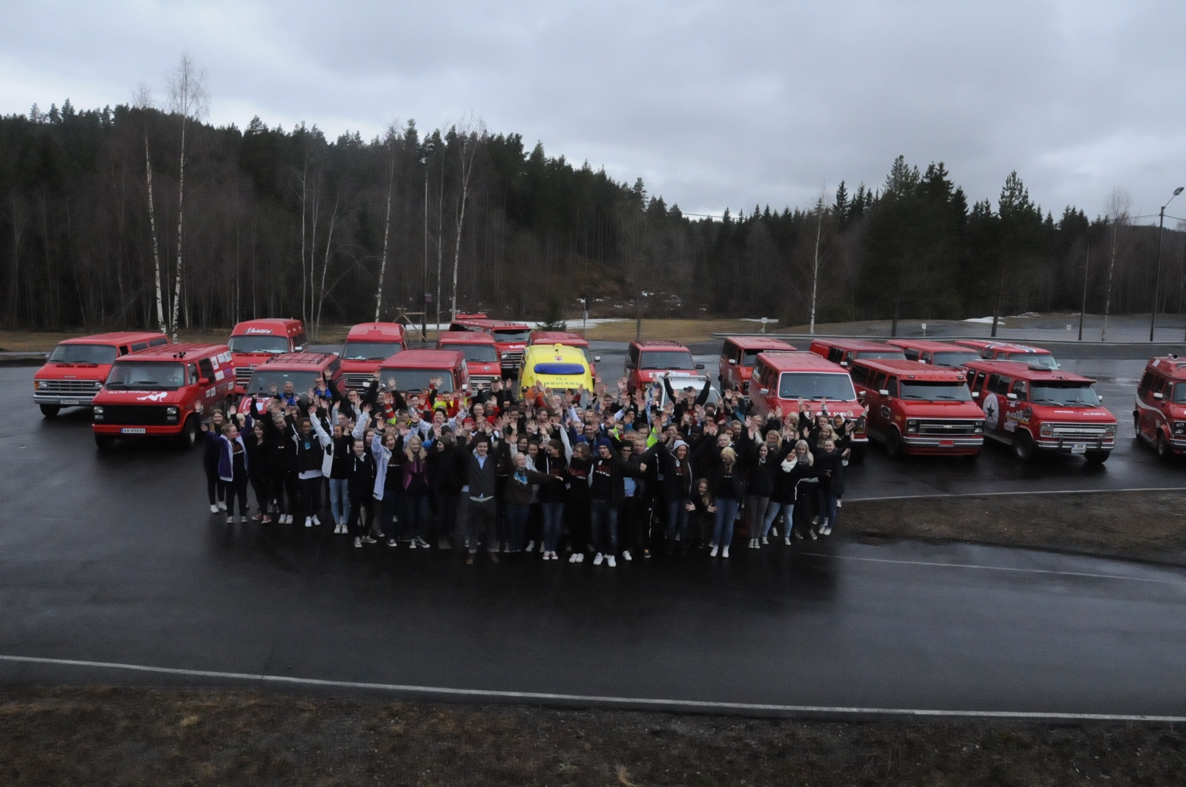

Seminar på Scandic Hotel Central
Torsdag 28. oktober 2021

Arr: Trygg Trafikk, Innlandet fylkeskommune, Politiet og Statens vegvesen

VELKOMMEN!

Vi har ingen å miste! Russetida – det siste skoleåret - skal være et minne for livet - et godt minne.
Politiet, Statens vegvesen og Trygg Trafikk - samt andre samarbeidspartnere - vil bidra til at dere får en god tid. Bruk oss for å bli beredt til de nye utfordringene som følger med det å være avgangselev.

Lykke til!

Marianne Mittet Solbraa
Regionleder Trygg Trafikk Innlandet

VÅR TRAFIKKSIKKERHETSDAG
Idemyldring ved bordet:

Tid: 10 minutter
Opplegg: Alle tenker i ett minutt
Hør ideer: Den enkelte presenterer en ide hver
Skriv ned alt!

____________________________________________________________________________________________________________________________________________________________________________________________________________________________________________________________________________________________________________________________________________________________________________________________________________________________________________________________________________________________________________________________________________________________________________________________________________________________________________________________________________________________________________________________________________________________________________________________________________________________________________________________________
________________________________________________________________________________________________________________________________________________________________________________________________________________________________________________________________________________________________________________________________________________________________________________________________________________________________________________________________________
________________________________________________________________________________________________________________________________________________________________________________________________________________________________________________________________________________________________________________________________________________________________________________________________________________________________________________________________________
________________________________________________________________________________________________________________________________________________________________________________________________________________________________________________________________________________________________________________________________________________________________________________________________________________________________________________________________________
SIKKER RUSSEBIL / KJØRETØY

Mine notater:

____________________________________________________________________________________________________________________________________________________________________________________________________________________________________________________________________________________________________________________________________________________________________________________________________________________________________________________________________________________________________________________________________________________________________________________________________________________________________________________________________________________________________________________________________________________________________________________________________________________________________________________________________
________________________________________________________________________________________________________________________________________________________________________________________________________________________________________________________________________________________________________________________________________________________________________________________________________________________________________________________________________

____________________________________________________________________________________________________________________________________________________________________________________________________________________________________

Hva kan vi ta med til vårt arrangement?
____________________________________________________________________________
________________________________________________________________________________________________________________________________________________________________________________________________________________________________________________________________________________________________________________________________________________________________________________________________________________________________________________________________________

SAMSPILL MED POLITIET
Mine notater:

____________________________________________________________________________________________________________________________________________________________________________________________________________________________________________________________________________________________________________________________________________________________________________________________________________________________________________________________________________________________________________________________________________________________________________________________________________________________________________________________________________________________________________________________________________________________________________________________________________________________________________________________________
________________________________________________________________________________________________________________________________________________________________________________________________________________________________________________________________________________________________________________________________________________________________________________________________________________________________________________________________________

____________________________________________________________________________________________________________________________________________________________________________________________________________________________________

Hva kan vi ta med til vårt arrangement?
____________________________________________________________________________
________________________________________________________________________________________________________________________________________________________________________________________________________________________________________________________________________________________________________________________________________________________________________________________________________________________________________________________________________

ET NAVN I ULYKKESSTATISTIKKEN
Mine notater:

____________________________________________________________________________________________________________________________________________________________________________________________________________________________________________________________________________________________________________________________________________________________________________________________________________________________________________________________________________________________________________________________________________________________________________________________________________________________________________________________________________________________________________________________________________________________________________________________________________________________________________________________________
________________________________________________________________________________________________________________________________________________________________________________________________________________________________________________________________________________________________________________________________________________________________________________________________________________________________________________________________________

____________________________________________________________________________________________________________________________________________________________________________________________________________________________________

Hva kan vi ta med til vårt arrangement?
____________________________________________________________________________
________________________________________________________________________________________________________________________________________________________________________________________________________________________________________________________________________________________________________________________________________________________________________________________________________________________________________________________________________

HELSE OG TRIVSEL
Mine notater:

____________________________________________________________________________________________________________________________________________________________________________________________________________________________________________________________________________________________________________________________________________________________________________________________________________________________________________________________________________________________________________________________________________________________________________________________________________________________________________________________________________________________________________________________________________________________________________________________________________________________________________________________________
________________________________________________________________________________________________________________________________________________________________________________________________________________________________________________________________________________________________________________________________________________________________________________________________________________________________________________________________________

____________________________________________________________________________________________________________________________________________________________________________________________________________________________________

Hva kan vi ta med til vårt arrangement?
____________________________________________________________________________
________________________________________________________________________________________________________________________________________________________________________________________________________________________________________________________________________________________________________________________________________________________________________________________________________________________________________________________________________

VÅR TEMADAG:

Hva gjør vi umiddelbart etter 28.10?

- informere om det vi tar med oss fra denne dagen
- bli enige om eller informere om tidspunktet (dag og tid) som er satt av til vår sikkerhetsdag
- lage en plan for arbeidet fram mot dagen:
  - hvem må involveres (elever, lærere, m.fl)?
  - trenger vi flyer, plakat eller liknende?
  - avtaler med foredragsholdere, hvem kontakter hvem?
  - avtale rom
  - rigge rom
  - ordne utstyr (pc, prosjektor, lerret?)
  - kontakt med presse/media
  - servering? lunsjpause?

Mine notater:

____________________________________________________________________________________________________________________________________________________________________________________________________________________________________________________________________________________________________________________________________________________________________________________________________________________________________________________________________________________________________________________________________________________________________________________________________________________________________________________________________________________________________________________________________________________________________________________________________________________________________________________________________

UTKAST TIL KJØREPLAN FOR DAGEN

Her skriver dere inn en kronlogisk oversikt for dagen. Start med oppmøte for dere som arrangerer og marker alle handlinger gjennom dagen. Vær detaljerte og tydelige. Merk at dette ikke er et program, men arbeidsplanen for dere som arrangører.

Når | Overskrift | Innhold | Ansvar | Info til
VÅRE AVTALER:

Instans | Person | Telefon/e-post | Tema? | Vår kontakt/  ansvarlig

Det er viktig at dere komponerer en dag som oppleves som god og riktig for russen hos dere. Aktuelle foredrag og innslag kan kommer fra Politiet (lokalt), Statens vegvesen, skolehelsetjenesten, personer som er personlig berørt, men det kan også være færre eller flere som dere mener bør kontaktes. Gjør gjerne avtaler her og nå i dag. Hvis ikke dato er spikret, kan dere likevel be personer om å holde av noen aktuelle datoer.

Nyttige lenker:
Tryggtrafikk.no
russpavei.no

Se også filmer på You tube med søkeord trygg trafikk.

